Kirin Harrington (NCFE10)

Kirin@twosmallpeople.co.uk

NCFE Level 2 Technical award in interactive media

Kirin Harrington

Contents

Introduction 3

Chosen interactive media product 3

Forms of interactive media products 3

Virtual reality 3

Augmented reality 4

Interactive PowerPoint 4

Website 5

Target audience 5

Platform/device 6

Virtual reality 6

Augmented reality 6

Interactive PowerPoint 6

Website 6

My choice of interactive media product 6

type of product 6

Features and services 6

House style 7

Colours 7

Fonts 7

Sans serif vs serif fonts 7

My choice of fonts 8

Mood board 8

Layout 9

Sitemap 9

Wireframes 10

Home page wireframe 10

Places to find help page wireframe 11

Forum page wirefram 12

File types/exporting options 14

Different file types 14

My choice of file types 14

Sources, processes and techniques 15

Experimentation with software solutions 16

WIX 16

Description 16

What i used it for 16

Basic setup 16

Courses page 18

Forums page 19

About page 20

Home page 22

Photoshop 24

Description 24

What i used it for 25

Evidence 25

Publisher 25

Description 25

What i used it for 25

Evidence 25

SNipping tool 25

Description 25

What i used it for 25

Evidence 26

Looka 26

Description 26

What i used it for 27

Evidence 27

Creation and preperation of assets 28

Directory and folder structure 28

File types 29

Asset creation 29

# Introduction

I have been asked by the mental health charity “Don’t Isol8” to create an interactive media product that will educate teenagers and young adults on how to improve mental health alongside encouraging open conversations when they are needed and give them access to support.

# Chosen interactive media product

## Forms of interactive media products

There are many different types of interactive media product and many different platforms that they work on, a few examples of these, alongside the features they can provide which would fit the brief I have been given, are listed below:

### Virtual reality

#### Pros

Virtual reality opens a whole new world of ways to display information and help people in a fun but also educational manner, this could involve a virtual reality “chat room” where the users could talk to each other in an open and anonymous environment, allowing them to talk freely about what’s on their mind without fear of being bullied for it.

It could also include games which allowed the user to learn more about mental health and ways to improve it, or even games which taught them important skills such as mindfulness or meditation techniques. It could also allow the user to take part in exercise, while in the world of virtual reality, which would allow them to connect to their friends at the same time and could provide a very valuable and immersive experience.

#### Cons

Although virtual reality provides an amazing space for users to talk and interact and enjoy themselves, it requires them to own a virtual reality headset, such as the oculus 2, which can be quite expensive and many people wont have access too, it also only allows the user to use it within their own home, which is not useful if the user needs support when they may be out and in a stressful situation, which is often likely, the anonymity also means that it’s possible for people to abuse their ability to speak freely and say harmful things, which would not positively affect someone mentally.

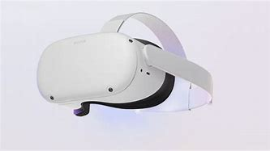

### Augmented reality

#### Pros

Augmented reality could be used as an app on a phone, which would provide accessibility and allow the user to use it wherever they go, which is a huge advantage, it could allow you to play games related to learning about mental health or encourage exercise through a game which requires you to run around collecting things.

It could also encourage the user to take part in mindfulness activities such as meditation, and even allowing users to communicate with each other, building friendships and opening up pathways for support, even over long distances

#### Cons

Not all phones work with AR, which means that it isn’t accessible to everyone, and not all environments will be suited for AR, it also distracts the user from the world around them which can be a problem as it can cause them to become disconnected and only involved in their phone.

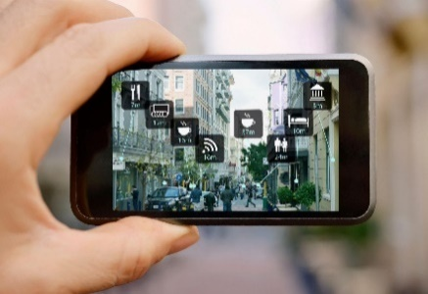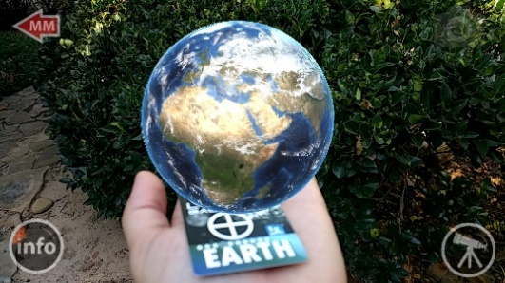

### Interactive PowerPoint

#### pros

Interactive PowerPoints can be shown on a TV screen basically anywhere, they allow the to swipe or tap to move on to a new screen which would give extra information on a certain area of mental health or ways to improve it, this could include videos and could also be made contactless with the use of sensors to remove any problems with breakages and any covid dangers. All media types, images, video and audio, would work well for this idea, images could be used in addition to text to provide information, allowing for a variety of ways to convey information, which could result in an intuitive and intuitive product.

#### cons

Interactive PowerPoints require a large screen or device and are stationary, meaning that the user would have to go and use one of them in a specific place, it would also mean that only a small number of people would have access to them and as it’s not portable they may not be able to use it when they need it the most.

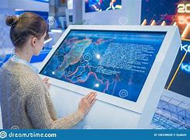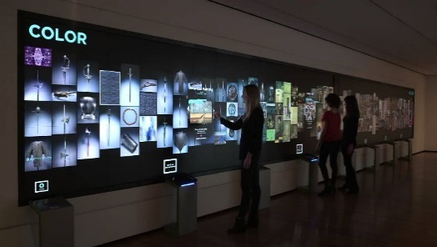

### Website

#### pros

A website is very portable, as users can access it from pretty much any device, allowing them to use It wherever they need to, it also allows for a variety of media methods such as images, videos and even games, alongside basic text to be used to convey information and allow the user to interact with the website in a variety of different ways, it could also provide a forum or a space for users to chat and talk about how they’re feeling, alongside information on other ways to get support or to improve their mental health condition.

#### cons

Websites can sometimes be slow if a lot of users are accessing them at once and require the user to have access to the internet, they also have a limited ability to provide support as they would have to refer the user to another service to do so.

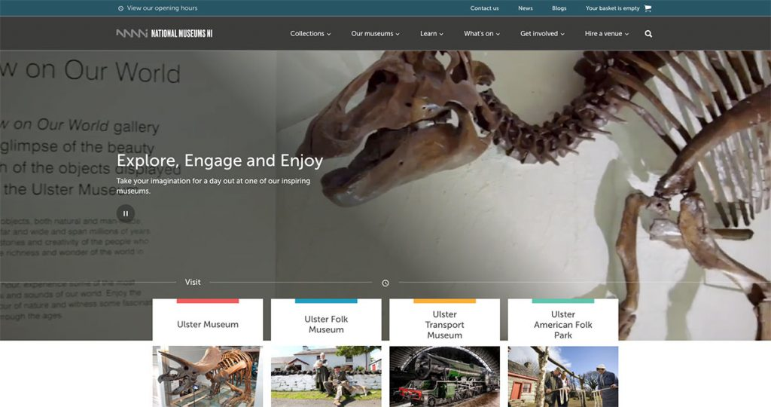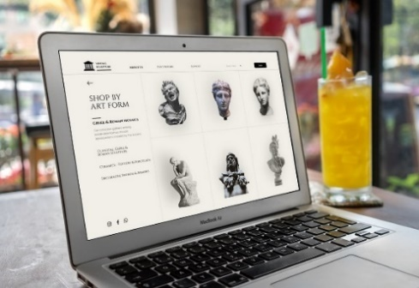

# Target audience

Considering the target audience when creating an interactive media product is very important, as you want to pick the correct platform and style to appeal to them, otherwise they may not enjoy using the product and may find it either too advanced, too basic, or even inaccessible.

## Platform/device

### Virtual reality

13+ Is very engaging and quite fun to use. However, it’s use is limited to people over the age of 13 because the headset will not fit on most young children. Some adults are wary and don’t feel comfortable with the technology as well, the chance of this seems to increase with the age of the adult, so the older the adult the higher the chance that they will refuse to use it.

### Augmented reality

3+ This would be useable by everyone as it is as simple as a phone app which needs little knowledge on how to use, apart from pointing it at the environment around you and reacting to what you see, it also appeals to a wide range of people as animations are interesting, especially to young audiences which could get them engaged and older audiences can focus more on the information.

### Interactive PowerPoint

5+ Useable by most with the exception of people who are too short to use the touch screen, this is easily fixed with a step or just a lower screen however, it would add an interactive element and can make a display more interesting for everyone rather than just blocks of text which some people may just ignore.

### Website

12+ Can be used by almost anyone as it is viewable on almost any device, it often contains more text and less interactivity and therefore is a lot less appealing to younger children, older children and adults also may have their own phone meaning that they don’t have to borrow their parents which improves accessibility.

# My choice of interactive media product

## type of product

For my interactive media product, I have chosen to go with a website as it is accessible to nearly everybody through a smartphone and can be used anywhere. A website is a simple yet highly effective way of conveying information and can appeal to users in a variety of ways, it fits the target age demographic of teenagers and young adults as they will nearly all have access to a smartphone and will understand how to use a website, it is also highly intuitive and can offer a range of features and ways to portray information, such as videos which could teach the user how to improve their mental health and the techniques to do so, as well as providing a space for users to chat or links to other services where they could get support.

## Features and services

My product will aim to offer a wide variety of features and services, which would include:

* A forum which would allow users to talk to each other and open up about issues they are facing
* Informational images, text and potentially videos which would allow the user to learn about different ways to improve their mental health and tech them how to apply them
* Inform users about events they can attend which will help them connect with others who have had similar experiences and make new friends, opening up more lines of support
* Inform users about exercise sessions near them and encourage them to take part in the exercise
* Offer instructions on how to perform mindfulness exercises
* Offer interactive quizzes to help the user learn about potential mental health issues and how to support others with them

# House style

## Colours

As it is a mental health app for teenagers and young adults I have chosen to go with cool and calming colours, as the experience needs to be relaxing and supportive and develop a sense of calm and safety in the user, allowing them to talk freely without being too scared to do so. Bright colours would have appealed a lot more to a younger audience and could be overwhelming, especially if the user is already stressed. I chose colours mainly related to blue as “Blue calls to mind feelings of [calmness](https://www.verywellmind.com/ways-to-calm-down-quickly-when-overwhelmed-3145197) and [relaxation](https://www.verywellmind.com/tips-to-reduce-stress-3145195). It is often described as peaceful, tranquil, secure, and orderly.” – taken from [The Colour Blue: Meaning and Colour Psychology (verywellmind.com)](https://www.verywellmind.com/the-color-psychology-of-blue-2795815)

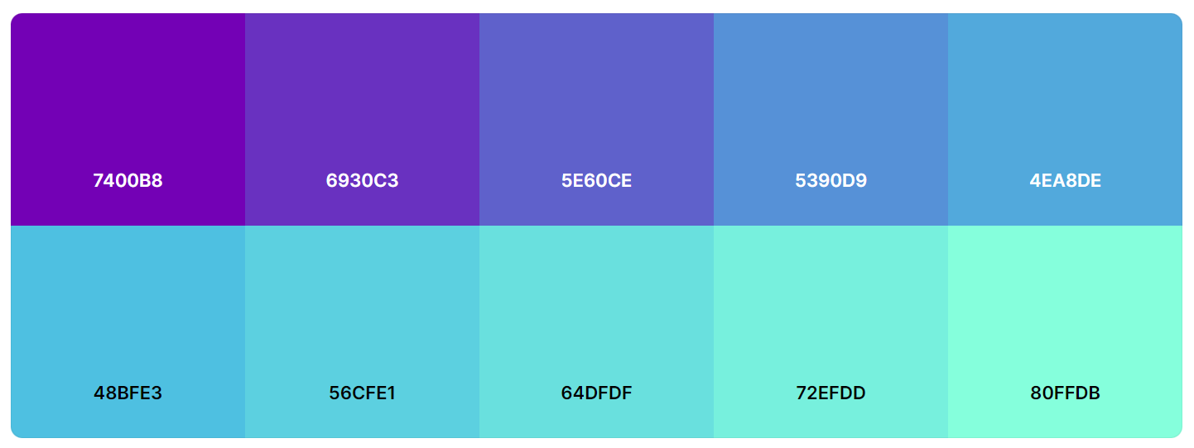

## Fonts

### Sans serif vs serif fonts

Picking between Sans-Serif and Serif fonts can be a difficult and important choice, as it will change the overall feel and look of the website and may make it harder to read and understand for some people with worse eyesight or conditions like dyslexia.

#### Sans serif

Fonts such as “Arial” and “Daytona” are examples of Sans-Serif fonts, as they don’t have extra lines (or “serifs”) attached to the letters, this results in a much more formal and orderly look, and can be a lot easier to read, especially in bulk and with smaller font sizes, it is also a lot easier for people with bad eyesight or conditions like dyslexia to read, which is very important when creating a website which needs to be accessible to everyone.

#### serif

Fonts such as “Segoe Script” and “Forte” are examples of Serif fonts, as they involve extra lines, which can improve the look and highlight areas of text, causing them to be look more professional, especially in titles.

### My choice of fonts

#### Font type

For my interactive media product, I chose to go with a combination of “Helvetica” for the main body of text, and “Futura” for titles and headings, this is because the product needs to be accessible to all teenagers and young adults, and Serif fonts can be a lot harder to read, they also create a much more calming feel as they don’t require as much effort to read due to them being so much easier to understand.

#### Font size

For the size of the fonts I will use, I decided to go with 18 for headings and titles, and 14 for the main bodies of text, this is to ensure that they are easy to distinguish between, alongside also being large enough for anyone to read, which would improve accessibility, and allow all teenagers and young adults to use.

## Mood board

Having a mood board when creating a project can be very helpful as it allows you to get all your ideas down in one place and then return there if you need inspiration throughout the creation of the project, I collated images relating to the theme of my project to give me an idea of how it will look and what kind of images and areas will be contained on the site. I will refer to it to make sure I am sticking to the theme and creating a project which fits the target audience and goal which the brief has set out for me.

It covers a range of images and emotions whiuch relate to mental health issues and key ways to overcome them, such as friendship and support, this mood board will only be for personal use and not shared with anyone as the unages are creative commons licenced,

# Layout

Planning the layout of your project before you can create it can be very useful as you then have a goal in mind and can make sure you stick to it, to ensure that you create a coherent and useable product

## Sitemap

This is a simple and easy way to represent and visualise the way the pages in my project connect and how the user will move from one to another, which I will attempt to follow when creating my project

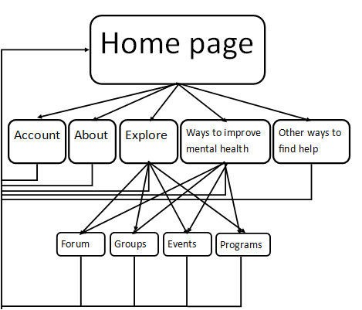

# Wireframes

I created these wireframes to give me an idea of how certain crucial parts of my website will look and I will use them as reference when I’m creating it. Wireframes provide a basic outline of the project, showing where things will be located, they also hold import information such as colours, fonts and font sizes.

### Home page wireframe

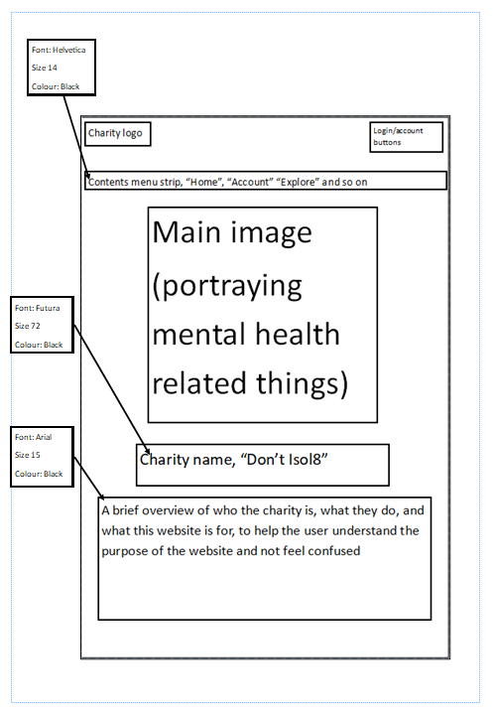

This is the wireframe for my home page, I chose to go for a coherent and simple design so it doesn’t overwhelm people who may be new to the website, it is also a familiar and common design which allows it to be accessible for everyone without confusion, the familiarity would also help users feel more at home and in a more relaxed state of mind which would likely make them more open to receiving help.

The immediate introduction of the logo and name of the website would help users know where they’re getting help from and could help build a sense of trust between them alongside also being memorable so they can share the website with others who made need help.

I choose to use a navigation bar as it is very commonly used and easy to understand, and its position at the top of the screen allows the user to access it easily and quickly find the part of the website they need, which would allow people to find support as quickly as possible.

### Places to find help page wireframe

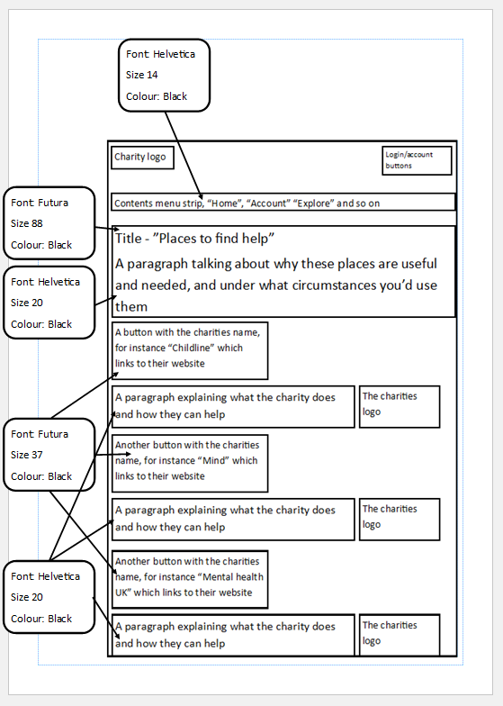

This is the wireframe for my place to find help page, I deliberately created this in a fashion similar to the home page to create a feeling of connection and to ensure that the users aren’t confused, to do this I kept the top of the page the same, with the logo and menu strip remaining constant, I also used the same font and text size and tried to make the layout as intuitive and simple as possible, so the users can quickly identify which charity they can use to get the help they need and access that charities website through a button as fast as possible.

I made sure to incorporate the logos of the other charities as they are likely to be well known so the user will trust them more and can then find them again if they need to.

I also used large and easy to read fonts to quickly and easily convey the message to all audiences, so the website is accessible for everyone.

### Forum page wirefram

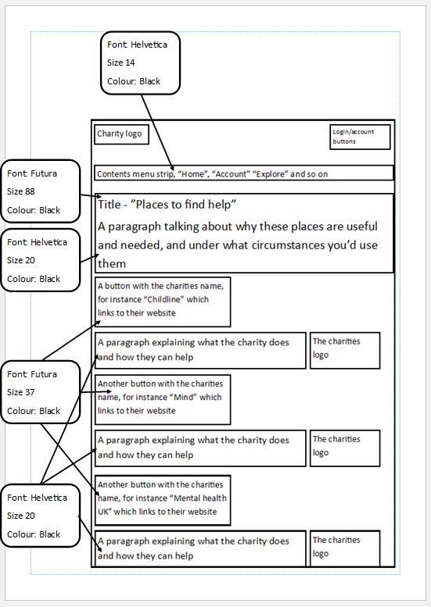

This is the wireframe for my forums page. I made sure to continue the same style

WRITE THIS WITH REFERENCE TO THE FORUMS WIREFRAME

# File types/exporting options

## Different file types

|  |  |
| --- | --- |
| MP4 | MP4 is a file type that is used for storing audio and video alongside images and subtitles, it is widely supported across devices and is very good for streaming over the internet, it also supports compression which would be ideal for websites as smaller files would load faster and provide a more professional feel overall, and the decreased quality won’t be noticeable for most devices. It uses lossy compression, however, which means that any removed data is permanently lost. |
| AVI | AVI has an extremely high quality, and doesn’t need any specific hardware or software to run, which matters less when it is embedded in a website, it lacks the ability for user interaction however, which means that pause and play features don’t exist, and they can also be very large if uncompressed which means they aren’t a good choice to use in websites as they would take a very long time to load. |
| Gif | Gifs allows for transparency, this gives the option to transfer image files to animations. Gifs use lossless compression which allows for higher quality images as no information is actually lost, however they have a restricted number of colours and don’t support shadows. They would work quite well for a website as they are small and quick to load as well as having the potential to look very professional. |
| Jpeg/Jpg | The best file type choice for image compression, however they compromise on image quality when compressed. When they are not compressed, they can be very high quality and often used in the photography industry. Unfortunately, they don’t support transparency making it difficult to change the image background. I will use these as the primary image file type in my website due to the quality and their small file size. |
| Png | PNGs are Ideal for digital art and use a lossless compression type to make sure the image is high quality, however, they are usually one of the largest image file type and not great for photography. They could still work very well for a website however, as the file type isn’t too large, and the high quality makes up for it in most scenarios. |
| Bmp | BMPs have very good image quality but they don’t support effective image compression and can therefore be extremely large especially if they contain a large number of colours. Because of this they wouldn’t work well for a website as they would take an unreasonable amount of time to load and wouldn’t add anything that another image file type could. |
| Mp3 | MP3s are audio only files and support compression and therefore can have a very small file size, this means that a website would be able to load and stream them very quickly. However, they only use lossy compression meaning that converting to a different file format will result in degrading audio quality. |
| WAV | WAVs are an uncompressed format which means there is no loss in audio quality therefor the audio is relatively easy to edit, and it allows us to listen to very high audio quality. However, wav files are incredibly large and can reach sizes of 500MB and therefor impractical for the website due to their extortionate file size. |
| MOV | MOVs can hold different media elements such as audio and video in one place, however, MOV files work exclusively on the QuickTime media platform so they would not function inside of a website and are therefore not suitable for this project. |

## My choice of file types

I chose to use MP4s for videos, as this would enrich the experience of users using the website alongside adding interactivity and making it more interesting, especially for younger uses and for transferring information in a way that text cannot, I chose to use a combination of JPEGs and PNGs for image files as the difference in file size won’t be noticeable on the website and both have very high quality alongside being small enough for them to load quickly, in addition to this I will add Gifs if I have time as they are small and compact and add a very professional feel.

# Sources, processes and techniques

I will use a variety of sources to create my website, these will include things like YouTube tutorials, other mental health website to gain inspiration such as Mind, and general research into mental health and the troubles which it can bring.

Some of the images I use for the website will not be free to use, which means that the cost of creating the website would be higher, **these images will be credited at the bottom of my website.**

Alongside those images I will also use images I have created myself, alongside stock photos which are free to use, I will find these images using Google Images, using these would lower the overall cost of creating the website.

I will also create a table below and list all the licensed images alongside the source below

|  |  |
| --- | --- |
| Image | Source |
|  |  |
|  |  |
|  |  |
|  |  |

Creating the interactive media project

# Experimentation with software solutions

# WIX

## Description

Wix is a free online website development tool which helps you create professional looking websites without having to write out lots of HTML to make it work, I used it throughout my project as it was the primary piece of software used to create my website.

Wix is a free, cloud-based website builder and content management system that allows users to create and design professional-looking websites without the need for coding or technical skills. Wix provides a user-friendly drag-and-drop interface and a range of customizable templates which allows users to easily create, edit and publish their own website.

Wix also offers features such as e-commerce integrations, mobile optimization, and social media integration, making it a comprehensive solution for small businesses and individuals looking to establish an strong and professional online presence.

## What i used it for

### Basic setup

|  |  |
| --- | --- |
|  | In this screenshot you can see me beginning the process of creating a website, I chose the category of website that I will create, this will help WIX recommend pages and extensions that would fit the category, I choose “mental health support group” as the website needs to fulfil the purpose of allowing the user to find support and connect to their peers, building up connections between them. |
|  | Here you can see me select modules that I believe will be beneficial to the website, such as a “groups” page and a “forums” page, so that they can be added to the website. |
|  | In this image I am selecting a style for the website to follow, I picked the calm theme, as I want the website to be relaxing and easy to navigate, to create a calm and peaceful experience for the user. |
|  | In this screenshot I picked a template to use for the website, I picked the one on the far right as it was the most similar to my wireframes and will save me time in the creation of the website as I only need to edit it. |
|  | Here I picked some pages to add to me website, such as an About page which would allow the user to learn about the charity, so they have a better idea of who will be helping them. |
|  | In this image I am editing the text and the font of the text to match the fonts I used in my wireframe, as I hope that will create an easy to read and simple introduction to the website that will be easy to follow. |
|  | In this screenshot I am changing the size of the text so this matches the wireframe, and so it will be easier to read and more accessible for users accessing the website. |
|  | Here I am changing an image from a default one provided by WIX to one which fits the theme of the website and will hopefully help users recognise the charity. |
|  | In this image you can see me adding a link to a certain area of text, allowing the user to quickly be sent to another website without them having to search for it specifically. |

### Courses page

In the courses section I created a template for a meditation course with some example steps to show how it would work if put into action.

|  |  |
| --- | --- |
|  | In this screenshot you can see an overview of the meditation course I have created, which users can sign up for and access  I have implemented certain features such as a progress bar and separate sections for different parts of the course, as well as being able to see which parts you have completed. |
|  | In this screenshot you can see the process of creating this meditation course, where I have added an image alongside a name and description to make the course seem more appealing to users |
|  | In this screenshot you can see how the course would appear to a user, with useful features such as the price and if they’re a participant being displayed |

### Forums page

In the forums section I created a fully working forum which allows users on different devices to communicate with each other in various categories such as “Connect and chat” and “Support and help” and react to and comment on each other’s messages

|  |  |
| --- | --- |
|  | In this screenshot you can see an example of the feature in action with posts being replied to, and even a feature allowing you to follow a post and receive an email notification when a new post is made |
|  | In this image you can see the creation of a forum category, which determines the colour, heading, and text which is shown in that category |
|  | In this screenshot you can see the forums being displayed as they would be when the user first clicks on them, with different categories alongside new posts and the button allowing you to create a post |

### About page

On the about page, I added in the logo I created for the charity and then made a slideshow of images to inform the user about the company in an interesting and interactive way

|  |  |
| --- | --- |
|  | In this screenshot you can see the process of editing slides to create a professional slideshow for the user to interact with |
|  | In this image I am adding an image which I have uploaded and then edited to fit the correct size |
|  | In this image you can see the process of adding a slideshow |

### Home page

On the home page I added an interactive quiz alongside buttons and information the user could look at and press which would lead them to different parts of the website to either sign up for groups or events which were upcoming, these update as new events and groups are created.

|  |  |
| --- | --- |
|  | On the home screen I created and added a quiz which the user can complete to test their knowledge on common myths around mental health, at the end it will inform them of their score and show them the correct answer after every question |
|  | In this screenshot you can see me adding events which I previously created in the events section to the home screen, allowing them to link back to the events screen for the user to sign up for them |
|  | In this image you can see me adding groups which I previously created in the groups section to the home screen, allowing them to link back to the groups screen for the user to sign up to them |
|  | In this image you can see the chat feature which I created that allows the user to talk to an admin of the website and get help quickly on issues they may be having. |
|  | In this image you can see me creating the quiz about mental health myths, containing the correct answers and how it will all be displayed |

# Photoshop

## Description

Adobe Photoshop is a professional image editing software used by photographers, graphic designers, and digital artists to create and modify images and graphics. It provides a wide range of tools and features, such as selection, painting, retouching, and compositing, that allow users to manipulate and enhance their images in a variety of ways. Photoshop also supports a wide range of file formats, making it a comprehensive solution for both raster and vector graphics. Additionally, it integrates with other Adobe Creative Cloud products, allowing users to easily transfer their work between applications. Photoshop is widely recognized as the industry standard for image editing and is used by professionals around the world.

## What i used it for

### Evidence

# Publisher

## Description

Publisher is a desktop publishing software developed by Microsoft as part of its Office suite. It allows users to create and design professional-looking documents, It provides templates, themes, and even design elements that make it easy for users to create appealing and eye-catching designs without the user needing to have a lot of graphic design skills. The software also allows the user use of basic image editing capabilities, such as cropping, resizing, and adding text and shapes, as well as the ability to import graphics from other sources. Publisher is a user-friendly solution for businesses, organizations, and individuals looking to create visually appealing documents for print or digital distribution.

## What i used it for

I used publisher for creating the wireframes I used for the planning of my project, but also to edit some images I used in the creation of my images as it was pre-installed on the computer I was assigned to and is a useful tool for editing images.

### Evidence

# SNipping tool

## Description

Snipping Tool is a built-in screenshot utility in most Windows distributions that enables users to capture a certain portion of their screen and save it as an image file, or just copy and paste it. It provides various modes for capturing screenshots, including full-screen, rectangular, and free-form, allowing users to choose the right one for them. The tool also has basic image editing capabilities such as highlighting, annotating and adding text to the screenshot. The snipped image can then be saved, copied to the clipboard, or email directly from the tool. This means that Snipping tool is an easy and free way to capture screenshots in a seamless manor.

## What i used it for

I used snipping tool to edit parts of images for my website, alongside using it to capture evidence of my website to use in this document.

### Evidence

|  |  |
| --- | --- |
|  | Here you can see the menu of snipping tool and the options it gives of creating snips, I will be using this a lot throughout the creation of my project to capture evidence and use for evidence |
|  | In this screenshot you can see me choosing the correct more of snipping tool for the purpose I need it for |
|  | In this image you can see me capturing evidence of my sitemap from publisher to use in this document, it’s also an easy way to transfer images through copy and paste |

# Looka

## Description

Looka is an artificial intelligence-powered logo generator that allows users to design and customize logos for their businesses in a very short space of time. It uses machine learning algorithm to create logos based on user input, such as industry, style preference, and colour preferences, to generate unique and professional-looking designs. The platform features a user-friendly interface, a large library of templates, and a wide range of design customization options to ensure that users can create logos that accurately reflect their brand and fit their target audience. Once a logo is designed, a user can then download various file formats for use on various platforms, including websites, business cards, and social media. Looka provides an efficient and affordable solution for businesses in need of a high-quality logo.

## What i used it for

### Evidence

|  |  |
| --- | --- |
|  | In this image I am choosing the theme of the logo I am creating, to aid the Ai algorithm in creating a logo which would fit the theme |
|  | Here I am entering the name of the company to be included in the user, so the user can recognise the charity from them, and then are able to find them easier in the future |
|  | In this screenshot I am picking logos which I like, so the algorithm can create logos related to them, incorporating elements of their design. |
|  | In this image I am picking colours related to the theme of the website, that should hopefully induce a sense of trust in the user and make the logo more appealing to the target audience. |
|  | Here I am picking themes that are related to the website, so that the logo can reflect it. |
|  | In this screenshot I am looking through some of the logos that AI has created, to find one which best fits the theme of the website and will best create a sense of trust and security in the user. |
|  | Here you can see me editing the font of one of the logos it created to be easier to read. |
|  | In this image you can see me editing the text size, changing the background colour, and adding a symbol, however I decided that this logo did not fit the theme of the website and I used a different one in the end. |

# Creation and preperation of assets

# Directory and folder structure

Use of directory and folder structure is very important as it helps you organise your files and can then access them again if you need to, and drastically decreases the risk of losing them, and also makes finding files a lot quicker, in the images below you can see my folder structure which I used to keep my files organised while creating my interactive media project.

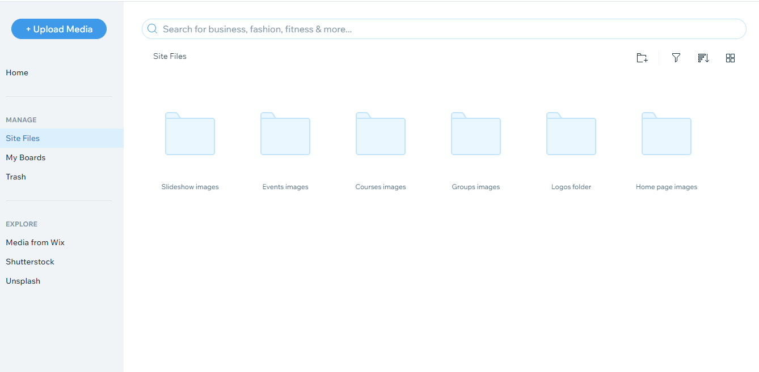

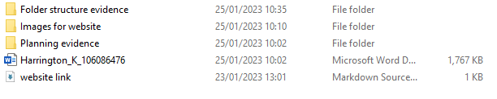

# hardware experiementation

I didn’t have access to a wide variety of hardware as I was sat in a controlled assessment with only the computer I was assigned to, I used the PC alongside an emulator to simulate a mobile environment, so I could see how the website would appear on my phone (as I wasn’t allowed to use it during the assessment).

The PC was

I did not have access to a variety hardware as I was in a controlled environment, but I used the PC given and my phone under supervision of the invigilator. The PC was more than suitable for my needs and did not struggle with most of the tasks that I completed. I used the PC to create my product and create the write-up. I used my mobile phone to check what the website looked like on a portrait device in real-time. There was an option on Wix that allowed me to edit the website in mobile phone mode however that did not allow me to see the published site, so I had to use my phone.

If I had had access to a graphics tablet then I would’ve created a logo for Don’t Isol8, however I didn’t so I had to create one using photoshop. This means that it is slightly lower quality than if I had been able to use a graphics tablet, however it sufficed.

I would’ve also used the tablet to view the website in different resolutions. This would let me see how well the website responded to different devices visiting it. If it didn’t look good on a specific resolution, then people may be less likely to spend time on the website which is not ideal because someone might not receive the help they need because of it.

If I had access to a less powerful PC or laptop, I would’ve looked at the website on a browser on there. That would let me know how well lower-spec machines could handle the website. This is important because I want all users to be able to view my website without barriers.

It would’ve also been useful to use old devices with older OSs and browsers. This would again, show me how the website performs when presented with less higher powered machines. If older machines and software cannot handle my website that would be a problem because it means that the website wouldn’t be accessible to everyone.

Review

# software?

# Strengths and weaknesses

## Strengths

## Weaknesses

# Areas for improvement

## Improvement areas

## Overall improvements